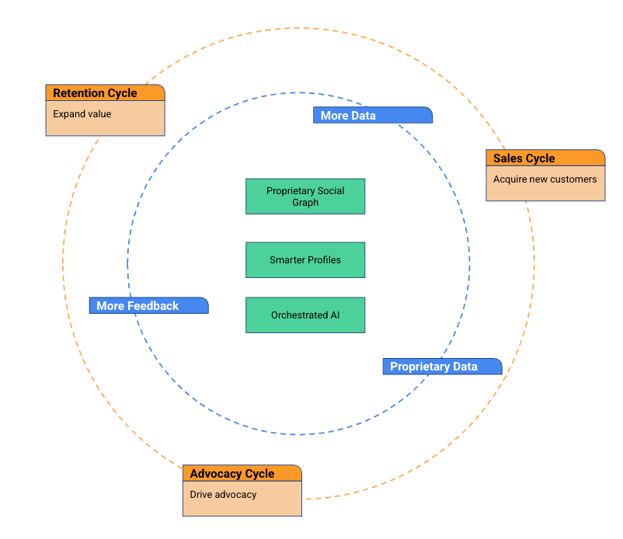

AI Orchestration: Transforming the Customer Engagement Industry
How Ambassador is Building the Future of Sales, Retention, and Advocacy Cycles
Executive Summary

Customer engagement has reached an inflection point. Over the last two decades, enterprises have steadily expanded their sales and marketing operations, pouring billions into systems, advertising, and headcount. For most companies, these two functions remain the single largest line items on the profit and loss statement. And yet, despite the enormous investment, the returns are declining.
The average enterprise marketing stack now includes over 120 tools (ChiefMartec, 2023). Paid acquisition costs on platforms like Google and Meta have risen between 20 and 40 percent in the last two years (WordStream, 2024). Meanwhile, customer trust in advertising is eroding—Edelman’s 2024 Trust Barometer found that while 76 percent of consumers trust recommendations from peers, only 38 percent trust advertising.
This combination—rising costs, diminishing returns, and falling trust—creates a crisis. Businesses are spending more, yet achieving less. Leadership teams and boards are increasingly aware that continuing down this path is not sustainable. The industry is broken and desperately in need of change.
The solution is orchestration. AI orchestration represents a fundamental shift from disconnected tools and linear funnels to connected systems that turn customer signals into coordinated actions across the entire lifecycle. It is the transition from automation, which simply executes tasks, to orchestration, which connects, adapts, and learns. McKinsey (2024) estimates that enterprises that integrate orchestration into their operating model see a 15 to 25 percent uplift in marketing ROI compared to those that do not.
Ambassador 3.0 is built for this moment. By combining referrals, affiliates, incentives, customer advocacy, communication, and Hiro—an AI-driven feedback engine—Ambassador acts as the orchestration layer enterprises need. The benefits are tangible: lower acquisition costs, higher retention, and advocacy at scale. We are not adding to the pile of tools. We are tearing down a broken industry and rebuilding it on cycles, signals, and orchestration.

The Industry at Breaking Point
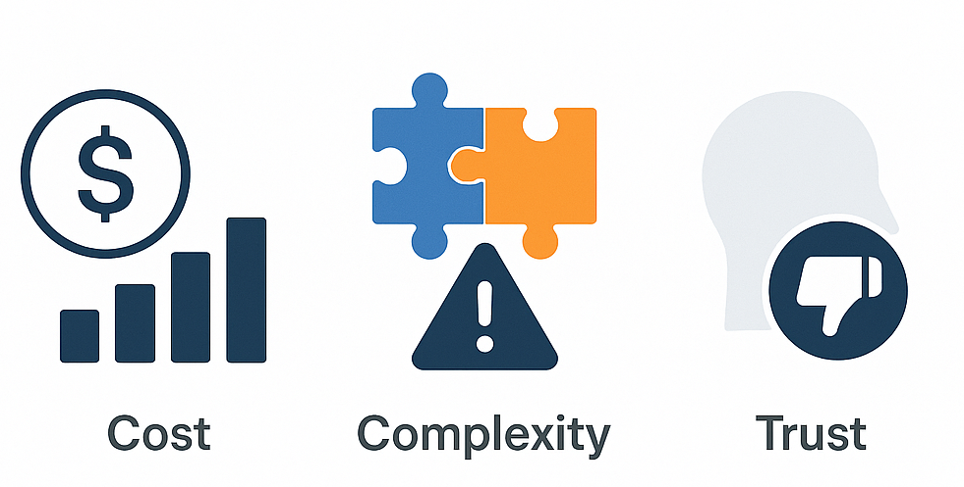
Enterprises today are spending more money than ever on sales and marketing, but the economics no longer make sense. According to Gartner (2024), B2B organizations allocate between 15 and 30 percent of their revenue to these functions, making them the most expensive line items on the P&L—surpassing even R&D in many industries. In theory, such investment should drive outsized growth. In practice, it is increasingly leading to inefficiency.
One reason is the sheer complexity of the marketing technology landscape. ChiefMartec’s 2023 report highlights that the average enterprise marketing stack contains more than 120 different tools. Each of these products may deliver value in isolation, but together they form a fragmented ecosystem where data is siloed, workflows are disjointed, and costs spiral out of control. Rather than simplifying engagement, these tools often add more confusion.
At the same time, the economics of digital acquisition are collapsing. Google and Meta, which have long dominated digital advertising, have seen costs skyrocket. WordStream data from 2024 shows average cost per click up between 20 and 40 percent across major verticals. Apple’s App Tracking Transparency and the deprecation of third-party cookies have further limited targeting capabilities, leaving marketers with fewer tools to reach the right audiences. The result is an industry where businesses are paying more and getting less.
Perhaps most damaging is the erosion of customer trust. Edelman’s 2024 Trust Barometer reports that while three-quarters of consumers trust peer recommendations, fewer than four in ten trust ads. Customers actively avoid channels where brands continue to overspend. The more money poured into traditional marketing tactics, the more resistance companies face.
This dynamic resembles Blockbuster in 2005—profitable on paper, but blind to shifting consumer behavior. The business model looked solid until Netflix orchestrated a new way to deliver value. Today’s engagement industry faces the same fate if it fails to evolve.
Lessons from Other Industries
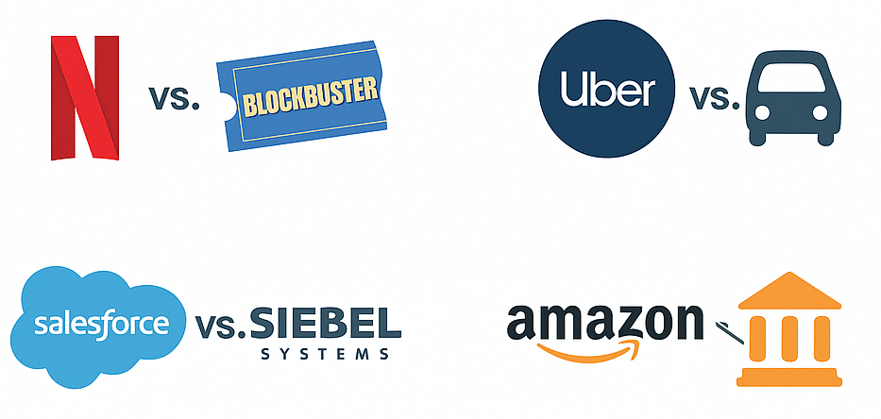
History provides a clear lesson: industries that fail to disrupt themselves are destroyed by new orchestrators. This pattern has played out repeatedly.
Netflix vs Blockbuster: Blockbuster built its empire on late fees and in-store rentals. It was profitable, but inconvenient. Netflix orchestrated content delivery into a subscription model, removing friction and eliminating late fees. Blockbuster collapsed within a decade.
Salesforce vs Siebel Systems: In the early 2000s, Siebel dominated the CRM market with expensive on-premise installations. Salesforce introduced a cloud-based model that orchestrated customer data seamlessly across teams and devices. Within years, Siebel lost relevance entirely.
Uber vs Taxis: Taxi companies operated in fragmented silos with inconsistent service. Uber orchestrated riders, drivers, payments, and navigation into a unified network. The result: taxi medallions that once sold for a million dollars in New York now trade for less than $100,000.
Amazon vs Department Stores: Department stores treated customers transactionally, while Amazon orchestrated logistics, personalization, and discovery into a self-reinforcing ecosystem. The flywheel of Prime, logistics, and recommendation engines made traditional department stores obsolete.
Each of these disruptions shares a common theme: orchestration replaces fragmentation. Customer engagement today is the next industry to face this reckoning. Ambassador is positioned to play the role that Netflix, Salesforce, Uber, and Amazon played in their respective categories.

What Is AI Orchestration?
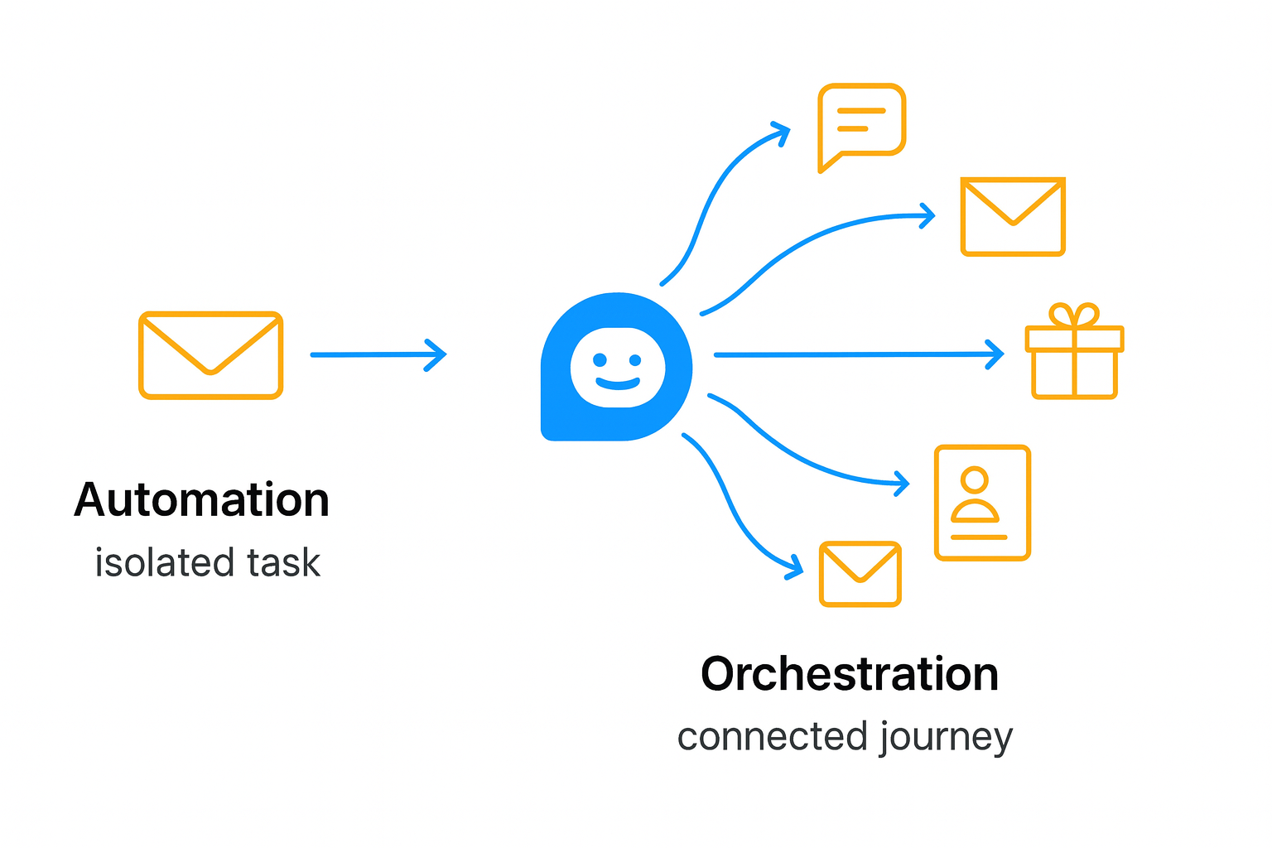
It is important to distinguish between automation and orchestration. Automation is about efficiency in completing a task. Orchestration is about coordination across the entire customer journey.
For example, automation might send an email at 9 AM when someone downloads a white paper. That task is completed, but it is disconnected from broader context. Orchestration, on the other hand, would connect the download to a larger sequence: HiroAI detects the signal, evaluates the customer’s profile, and determines that SMS is a more effective follow-up channel than email. It might also connect the signal to a referral program, offering an incentive for sharing with peers, while simultaneously alerting the account manager if the customer shows signs of churn.
This is why orchestration matters. It connects context, chooses the optimal channel, and adapts in real time. McKinsey (2024) reports that companies that adopt orchestration see marketing ROI improvements of 15–25 percent, while Forrester (2023) warns that 'enterprises can no longer afford to build MarTech stacks like Jenga towers—they must consolidate, integrate, and orchestrate.'
The combination of AI maturity, seamless APIs, and economic pressure makes now the right moment for orchestration to become standard.
The Cycles Framework
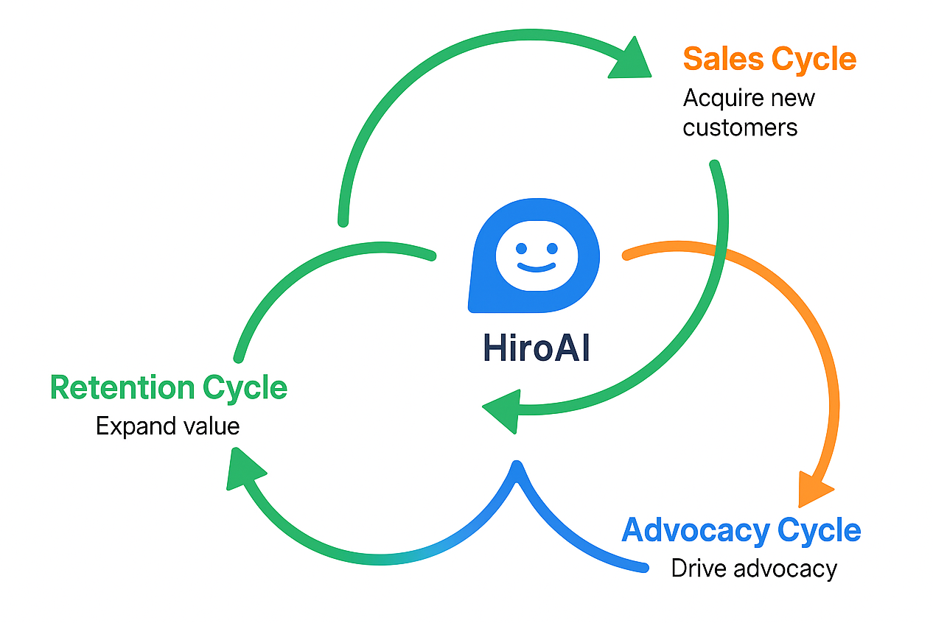
Traditional marketing funnels are linear: awareness leads to consideration, which leads to purchase. In practice, this model no longer holds. Growth today is cyclical, fueled by relationships rather than transactions.
Ambassador introduces the Cycles Framework: Sales, Retention, and Advocacy. These cycles are not independent—they are interconnected, compounding on one another to form a flywheel of growth.
Sales Cycle: Traditionally, acquisition has relied on cold outreach and expensive ads. In the orchestrated model, referrals, affiliates, and partnerships drive sales, lowering CAC by as much as 30 percent.
Retention Cycle: Instead of email blasts and discount campaigns, orchestration uses HiroAI to detect churn signals and activate loyalty triggers. This can reduce churn by 10–20 percent in the first six months of implementation.
Advocacy Cycle: Advocacy has often been treated as an afterthought. Orchestration changes this by automating review requests, case study submissions, and referral prompts. The result is a three- to five-fold increase in advocacy outputs.
These cycles reinforce one another. Advocates feed the sales cycle, loyal customers drive advocacy, and improved retention strengthens acquisition economics. Bain & Co famously found that 'increasing customer retention rates by just 5 percent can increase profits by 25 to 95 percent.' The Ambassador model is built to make these compounding effects tangible.
Ambassador as the Orchestration Layer
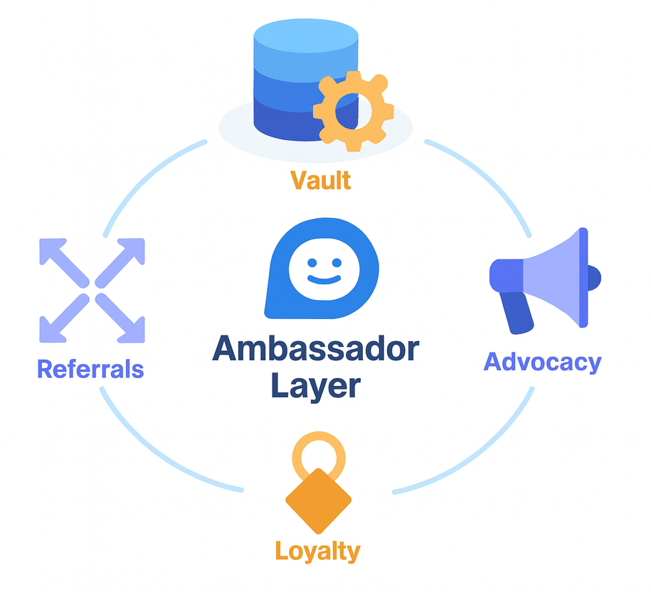
Ambassador 3.0 is not just another engagement tool—it is the orchestration layer for the customer lifecycle. At its core is HiroAI, which translates feedback and behavioral data into signals. These signals are orchestrated into actions across referrals, loyalty programs, incentives, and advocacy campaigns.
Ambassador also provides the infrastructure enterprises need. Vaults and ledgers ensure compliance, global payouts, and fraud detection. APIs connect Ambassador seamlessly to CRM systems, communication channels, and payment networks. Touchpoints like Snipplets allow deployment of engagement mechanisms across web, app, and in-product experiences.
The result is an engagement flywheel where each cycle compounds the next. Instead of juggling disconnected tools, enterprises orchestrate everything through a single layer.

Destroying the Old Guard
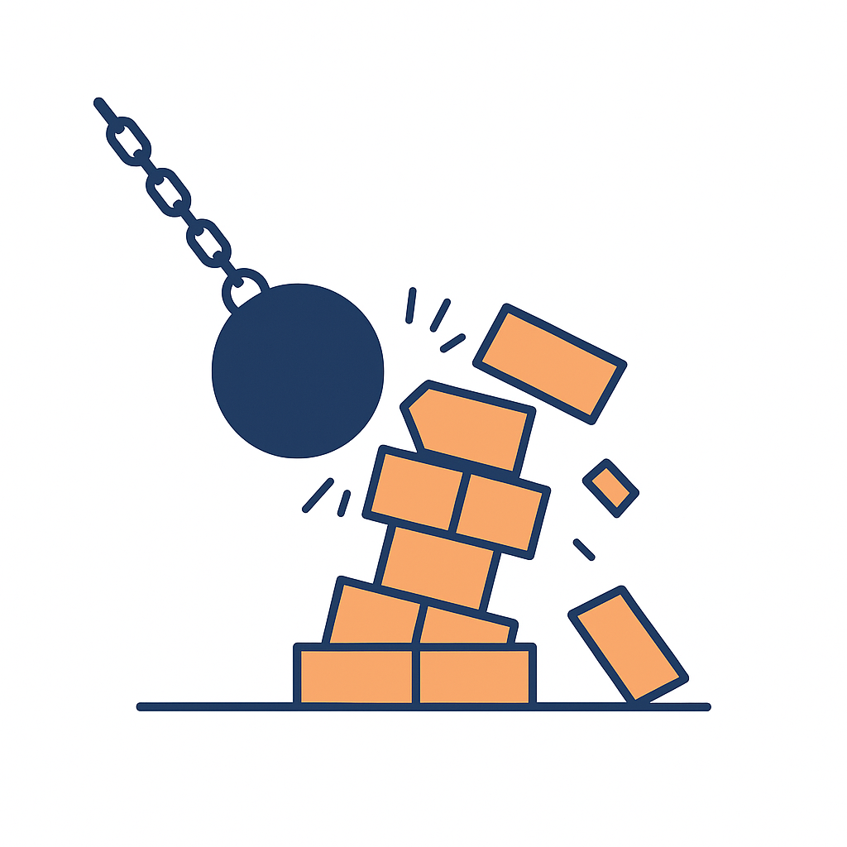
Referral, loyalty, and affiliate software has been stagnant for over a decade. These legacy vendors operate as isolated point solutions—useful in narrow contexts, but incapable of orchestrating the broader customer lifecycle. Agencies have filled some of the gap, manually orchestrating programs across systems, but at high cost and low scalability.
Ambassador renders both approaches obsolete. Just as Uber made taxi medallions irrelevant and Salesforce made on-premise CRM installations extinct, Ambassador makes point-solution vendors unnecessary. We don’t add another brick to the Jenga tower; we replace the tower with a platform designed for orchestration.
Forrester (2023) put it succinctly: 'The era of cobbled-together engagement stacks is over. The winners will be the companies that orchestrate, not accumulate.'

Proof Points & Case Snapshots
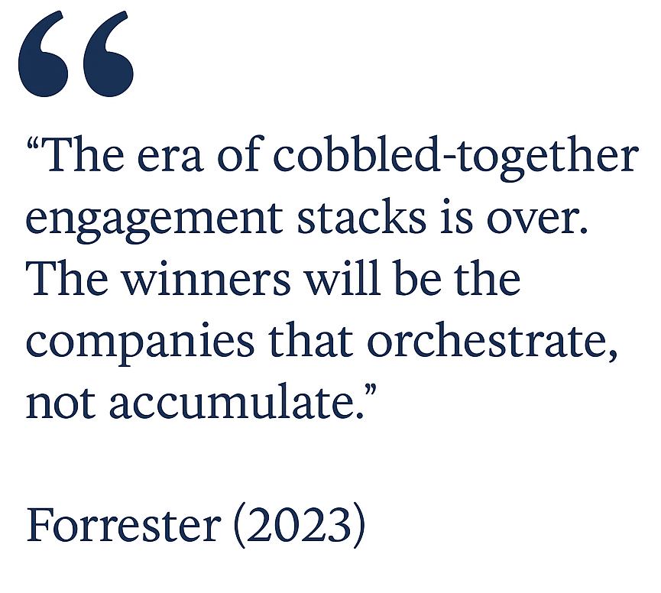
The value of orchestration is not theoretical—it is already being demonstrated in practice.
A leading FinTech enterprise consolidated four engagement vendors into Ambassador. Within nine months, they reduced CAC by 22 percent and improved NRR by 14 percent.
A global SaaS brand automated advocacy submissions through Ambassador, resulting in a three- to five-fold increase in G2 reviews and case studies year-over-year.
A major TelCo client used HiroAI to orchestrate retention signals. The system flagged more than 80 at-risk accounts each month, reducing churn by 18 percent.
As one VP of Growth at a Fortune 500 SaaS company put it: 'Ambassador replaced an entire stack of tools with one orchestrated platform. Our ROI doubled in less than a year.'

The Future We’re Building
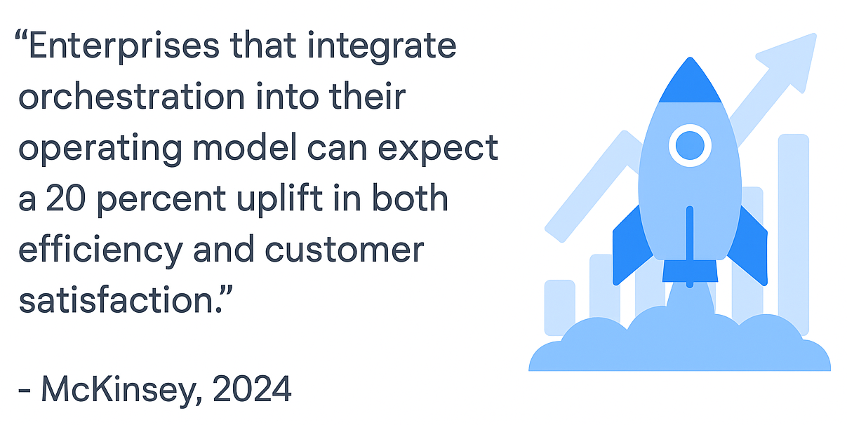
Ambassador 3.0 is the beginning, not the end. The roadmap for the coming years includes Ambassador 3.X—featuring AI fraud detection, surveys, and SMS integrations. Beyond that, the 2026 vision focuses on self-serve orchestration SKUs, AI-driven onboarding, and SMB-scale adoption.
The long-term North Star is clear: to become the world’s most connected AI-feedback and engagement network. This vision positions Ambassador as the operating system for customer engagement—an orchestration layer that turns conversations into signals, and signals into outcomes.
McKinsey (2024) projects that 'enterprises that integrate orchestration into their operating model can expect a 20 percent uplift in both efficiency and customer satisfaction.' Ambassador is committed to making that promise real.

Conclusion
Industries that fail to disrupt themselves are destroyed. Customer engagement is no different. The P&L pressures are real. The stacks are broken. The old guard is collapsing.
Ambassador is not just another software vendor. We are the orchestration layer—the system that connects cycles, reduces costs, and drives growth.
The future of engagement will not be built on point solutions. It will be orchestrated. The only question is: who will you orchestrate with?

